Explanation

Talha Yousaf

Project 1:

Objective:
The purpose of this project is to design a series circuit and calculate current and voltage across each resistor.

Components Used:
- Alternator (5V)
- Resistors:
  - R1 = 5.1kΩ
  - R2 = 3.3kΩ
- Connecting wires

Steps to Create Circuit in Proteus:
- Open Proteus software and create a New Project.
- Enter the project name and continue with default settings.
- Click on Pick Devices (P).
- Search and select:
  - Resistor
  - Alternator
- Place all components on the workspace.
- Set resistor values:
  - R1 = 5.1kΩ
  - R2 = 3.3kΩ
- Set alternator voltage to 5V.
- Connect resistors in series.
- Connect the series network across the alternator.
- Connect DC voltmeter and ammeter to check voltage and current.
- Complete wiring properly and run the simulation.

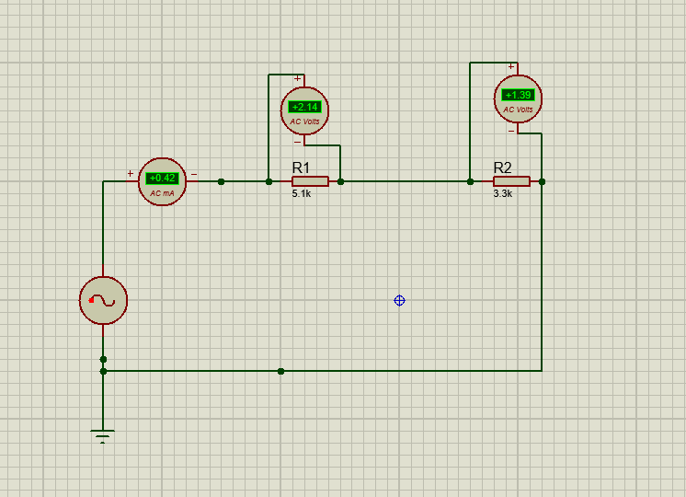
Project 2:

Objective:
The purpose of this project is to design a parallel circuit with three resistors and calculate total voltage and current distribution.

Components Used:
- DC Battery (9V)
- Resistors:
  - R1 = 10kΩ
  - R2 = 2kΩ
  - R3 = 1kΩ
- Connecting wires

Steps to Create Circuit in Proteus:
- Open Proteus and create a New Project.
- Enter project details and proceed with default options.
- Click on Pick Devices (P).
- Search and select:
  - Resistor
  - DC Battery
- Place all components on the workspace.
- Set resistor values:
  - R1 = 10kΩ
  - R2 = 2kΩ
  - R3 = 1kΩ
- Set battery voltage to 9V.
- Connect all resistors in parallel configuration.
- Connect the circuit across the battery terminals.
- Connect DC voltmeter and ammeter to check voltage and current.
- Check connections and run simulation.
